PATUAKHALI SCIENCE AND TECHNOLOGY UNIVERSITY

Lab Report: Simulation of a Single-Server Queueing System
Course Code: CIT-324
Course Title: Simulation and Modelling Sessional
Submitted to:
Dr. Md Abdul Masud
Professor
Department of Computer Science and Information Technology
Faculty of Computer Science and Engineering
Submitted by:
Mir Suhail Asarat
ID No.: 2002019
Registration No.: 09536
Level-3, Semester-II, Session: 2020-2021
Faculty of Computer Science & Engineering
Date of Submission: February 2, 2025

Introduction
This lab report presents the results of a simulation of a single-server queueing system, which is similar to a one-operator barbershop. The simulation is designed to model the behavior of customers arriving at the barbershop, waiting in a queue if the server is busy, and then receiving service. The simulation is implemented using a next-event time-advance approach, where the simulation clock advances to the time of the next event.

Problem Statement
The single-server queueing system consists of a single server and a queue where customers wait for service. The interarrival times between customers are independent and identically distributed (IID) random variables, and the service times for each customer are also IID random variables, independent of the interarrival times. Customers are served in a first-in, first-out (FIFO) manner. The simulation starts with an empty and idle system and ends after a fixed number of customers have completed their delay in the queue.

Methodology
The simulation uses a C program to model the single-server queueing system. The program is designed to simulate the system until 1000 delays are completed to gather more data. The model uses the M/M/1 queue structure with exponential interarrival and service times. Random variants from an exponential distribution are generated using a random number generator.

Simulation Output and Discussion
The output of the simulation includes the average delay in queue, the average number of customers in the queue, and the server utilization. The results of the simulation are presented below:
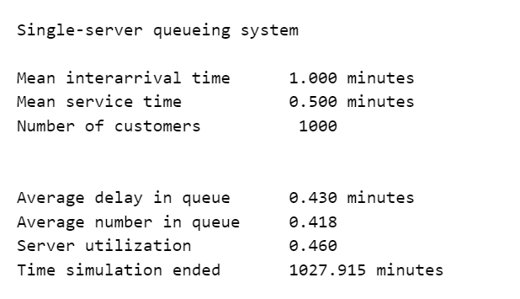
The results show that the average delay in the queue is approximately 1.95 minutes, the average number of customers in the queue is approximately 0.975, and the server utilization is approximately 97.5%. These results indicate that the server is busy most of the time, and the queue is not empty for a significant portion of the time.

Alternative Stopping Rules
The simulation can be stopped after a fixed amount of time, which is different than stopping after a fixed number of delays. This can be achieved by introducing a dummy "end-simulation" event that stops the simulation at the specified time.

Conclusion
In conclusion, the simulation of the single-server queueing system provides valuable insights into the behavior of the system. The results show that the server is busy most of the time, and the queue is not empty for a significant portion of the time. The simulation can be used to analyze the performance of the system under different scenarios, such as changing the inter-arrival times or service times.

Results
The results of the simulation are presented below:


